UNIVERSITY OF KALYANI

Smt, Minakshi Sarkar  Kalyani, Nadia, 741235

Secretary (offg.) Ph. 033-2582-6752, Extn.233/334

Faculty councils (UG) EPABX:2852-8750/8293

Email: ugfe@klyuniv.ac.in

No. FC /UG/ 386 / 24 Date: 22.10.24

**Decentralized Counselling for admission to the 1st Year of B.Tech Programmes of**

**Electronics and Communication Engineering (ECE) / Elecetronics and Instrumentation Engineering(EIE) / Information Technology(IT) offered by the Dept. of** **Engineering and Technological Studies, University of Kalyani for thesession AY 2024-2025**

### Date of Counseling: 24/October/2024 (Thursday).

### Reporting Date &Time : 24/October/2024 (Thursday) at 12 Noon.

### Venue: Annex Building, Department of Engineering and Technological Studies, University of Kalyani, Kalyani-741235, Nadia, West Bengal

### Details of Vacant Seats*:

|  |  |  |  |  |  |  |
| --- | --- | --- | --- | --- | --- | --- |
| **Name of the programme** | **UR** | **Reserved Category** | | | | **Total Vacant Seats** |
| SC | ST | OBC-A | OBC-B |
| Electronics and Instrumentation Engineering | **1** | **1** | **0** | **0** | **0** | **2** |
| Electronics and Communication Engineering | **3** | **0** | **0** | **1** | **0** | **4** |
| Information Technology | **1** | **0** | **0** | **0** | **0** | **1** |

**\*The vacancy is subject to change during the counseling process. The changed vacant seats will be informed before the counseling, if any.**

### Documents to be carried during Counseling and Admission

During the counseling in order to complete the admission process the students must carry:

* 1. 2 passport size color photos
  2. The following documents in original along with one photocopy of each document:
     1. AADHAR Card
     2. Admit Card of WBJEE 2024
     3. Rank Card of WBJEE 2024
     4. Class-Xth Admit Card / Birth Certificate for verification of Date of Birth
     5. Mark sheet of Class-Xth Examination
     6. Mark sheet of Class-XIIth Examination
     7. Valid Domicile Certificate in WBJEE prescribed format for West Bengal domicile candidates, if applicable
     8. Valid SC/ST/OBC-A/OBC-B certificate issued by the Government of West Bengal, if applicable. **OBC-A/B certificates must be issued on or after 01.04.2024. It must clearly mention that the candidate belongs to non-Creamy layer and sub-category of OBC-A or OBCB**.
  3. Tuition fee (Details available in **Appendix – I)** to be paid through digital payment method.

### DOCUMENTS TO BE SUBMITTED BEFORE COMMENCEMENT OF CLASSES:

* 1. Two Affidavits related to anti ragging compliance (both students copy and guardian's copy) – format attached in the **Appendix II.**
  2. The Medical Certificate for General Health, Eye and Blood Group (Original) to be obtained only from Gazetted Government Medical Officer / Medical Officer of Government Undertaking in the appropriate letter head of the Medical Practitioner – format attached in the **Appendix III.**

**University of Kalyani**

Provisional Combined Merit List for Decentralized Counselling for Admission tothe B.Tech. Programmes in ECE/EIE/IT at the DETS for AY (2024-2025)

|  |  |  |  |  |  |
| --- | --- | --- | --- | --- | --- |
| **Sl No.** | **WB JEE Roll** | | **WB JEE Rank** | **NAME** | **Student Category** |
| 1 | | 4012303201 | 4580 | AMAN RAJ | OBC-B |
| 2 | | 4013118256 | 5259 | DEEPAK KUMAR | General |
| 3 | | 4013209256 | 5488 | ANUBHAV SAMANTA | General |
| 4 | | 4014512162 | 5665 | VIKRANT RAJESH | General |
| 5 | | 4013005050 | 5687 | AMRITANGSHU BHANJA | General |
| 6 | | 4013003045 | 5821 | PRITHA ROY | General |
| 7 | | 4013216173 | 6153 | LAXMI BHARTI | General |
| 8 | | 4014514582 | 6238 | KUMAR RAUSHAN MEHTA | General |
| 9 | | 4013102372 | 6282 | CHANCHAL PRADHAN | General |
| 10 | | 4014002241 | 6397 | GOURAB SUTRADHAR | General |
| 11 | | 4014604610 | 6526 | AARAV SINHA | General |
| 12 | | 4012309247 | 6711 | ASHIF HUSSAIN | OBC-A |
| 13 | | 4013202498 | 6716 | ARPAN DAS | General |
| 14 | | 4012203201 | 6828 | RISHABH MAHATO | OBC-B |
| 15 | | 4012001159 | 6887 | PRAMIT KUMAR DHAR | General |
| 16 | | 4014306340 | 6975 | KOUSHIKI BHATTACHARYYA | General |
| 17 | | 4013306092 | 7183 | PRINCE KUMAR | General |
| 18 | | 4015004605 | 7355 | SOUMOJIT GON | OBC-B |
| 19 | | 4014201317 | 7567 | DEBAYAN CHAKRABORTY | General |
| 20 | | 4013807052 | 7825 | SUPARNA CHOWDHURY | General |
| 21 | | 4011001155 | 8021 | NILESH KARKI CHETTRI | General |
| 22 | | 4015304476 | 8070 | SANJANA MAITY | General |
| 23 | | 4015509179 | 8165 | SHIVENDU PAL | OBC-B |
| 24 | | 4013226265 | 8300 | SIDDHARTH KUMAR SONY | General |
| 25 | | 4013401238 | 8388 | DEVA NARAYAN MANDAL | General |
| 26 | | 4014305117 | 8476 | ARIYAN DUTTA | General |
| 27 | | 4012107052 | 8782 | SANCHARI BAG | General |
| 28 | | 4014305259 | 8796 | RITASMIT SARKAR | General |
| 29 | | 4012701001 | 9019 | AYAN ACHARYA | General |
| 30 | | 4013903095 | 9103 | MRINMOY BISWAS | General |
| 31 | | 4013117231 | 9564 | RAVI ROSHAN CHAUDHARY | OBC-B |
| 32 | | 4013106238 | 10043 | ANUJ KUMAR | General |
| 33 | | 4014803407 | 10102 | SAINA KARAN | General |
| 34 | | 4013803213 | 10258 | TUSHER KANTI CHAKRABORTY | General |
| 35 | | 4011903359 | 10434 | RIYAN KUNDU | General |
| 36 | | 4015503017 | 10504 | SWASTIKA BHATTACHARJEE | General |
| 37 | | 4014203219 | 10611 | PRATIK BISWAS | General |
| 38 | | 4014101027 | 11650 | AYON SAHA | General |
| 39 | | 4014002386 | 11677 | NITIN BALLABH | General |
| 40 | | 4014101167 | 11748 | KRISH MITRA | General |
| 41 | | 4015003407 | 12017 | ARIJIT KHASPURI | OBC-B |
| 42 | | 4014504082 | 12090 | RAJAN KUMAR | General |
| 43 | | 4011104461 | 12337 | ANKITA BANERJEE | General |
| 44 | | 4014610687 | 12820 | NIHAL PRASAD | General |
| 45 | | 4012501191 | 13433 | DISHA SASMAL | General |
| 46 | | 4014301077 | 13553 | SAGNIK BHATTACHARYYA | General |
| 47 | | 4014601500 | 14214 | JYOTISH KUMAR JHA | General |
| 48 | | 4013701044 | 14216 | SOMU DAS | OBC-B |
| 49 | | 4013501014 | 14400 | RONI PAL | General |
| 50 | | 4011601066 | 14641 | JUNAID SARKAR | General |
| 51 | | 4014306115 | 14991 | SUDESHNA HELA | SC |
| 52 | | 4013804121 | 15382 | RIK DEBNATH | OBC-B |
| 53 | | 4015509152 | 17406 | ARITRA BARMAN | SC |
| 54 | | 4012902188 | 18046 | CHINMOY MONDAL | SC |
| 55 | | 4013802431 | 18634 | AKASH DAS | SC |
| 56 | | 4014502083 | 18842 | ASIMA GARAI | OBC-B |
| 57 | | 4014908173 | 19831 | SUBHANKAR | EWS |
| 58 | | 4013004095 | 21797 | SUMENA MONDAL | SC |
| 59 | | 4015602417 | 22036 | JAIDUR HOSSAIN LASKAR | OBC-A |
| 60 | | 4012901131 | 23005 | DEBAJIT PAL | EWS |
| 61 | | 4014804057 | 23522 | SOUVIK GANDA | OBC-B |
| 62 | | 4013209257 | 23768 | BAPI MANDAL | SC |
| 63 | | 4013805304 | 26351 | NAYAN SARKAR | SC |
| 64 | | 4012502256 | 26918 | MAHAMMAD IMRAN KHAN | OBC-A |
| 65 | | 4013401009 | 27337 | MD ARYAN REHMAN | OBC-A |
| 66 | | 4013802149 | 28762 | ATRI SARKAR | SC |
| 67 | | 4015503066 | 28882 | PRANTICK NASKAR | SC |
| 68 | | 4011404254 | 29355 | ANIRBAN DEY | EWS |
| 69 | | 4015002519 | 30157 | SK SAHIL | OBC-A |
| 70 | | 4011002222 | 31248 | ADITYA GUPTA | OBC-B |
| 71 | | 4013802441 | 31643 | BIKRAM DAS | SC |
| 72 | | 4013004639 | 32303 | SOUJANYA HALDER | SC |
| 73 | | 4015103415 | 32551 | ARPITA PATTANAYAK | EWS |
| 74 | | 4015505112 | 32739 | MEHEBUB LASKAR | OBC-A |
| 75 | | 4014305414 | 32981 | ARYAN GUPTA | OBC-B |
| 76 | | 4012906433 | 33168 | TAMOGHNA GARAI | SC |
| 77 | | 4013801003 | 34311 | AGNICK GHOSH | OBC-B |

### Appendix – I : TUITION FEE DETAILS

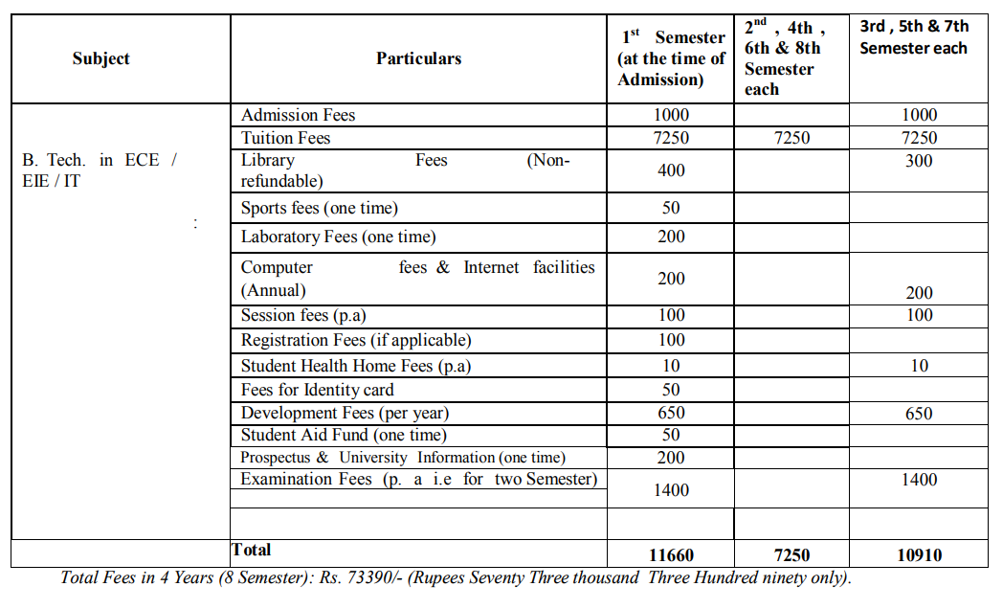

The total amount of Rs.11,660/- is to be paid at the University at the time of admission **IN DIGITAL PAYMENT METHOD ONLY.**

**Appendix – II : SAMPLE FORMAT FOR ANTI RAGGING AFFIDAVIT**

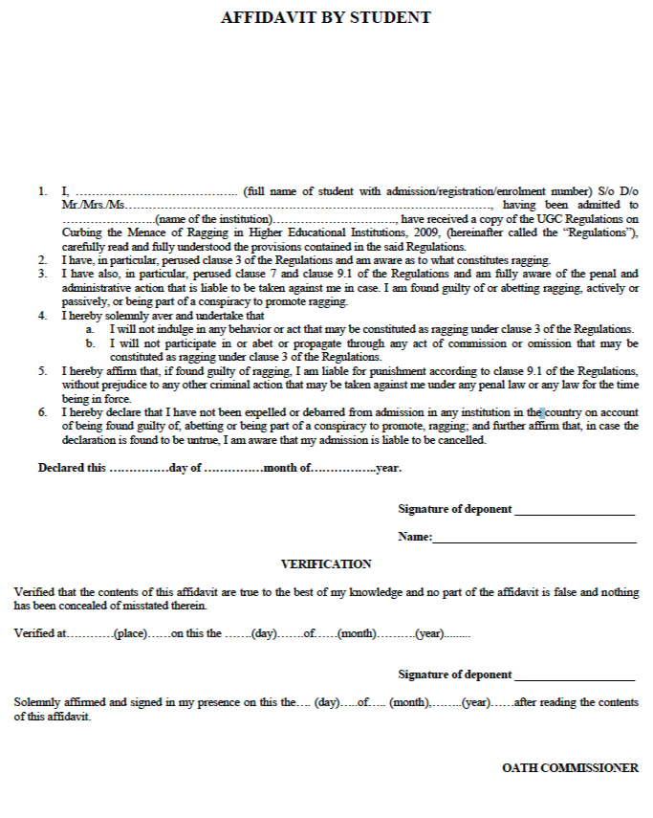

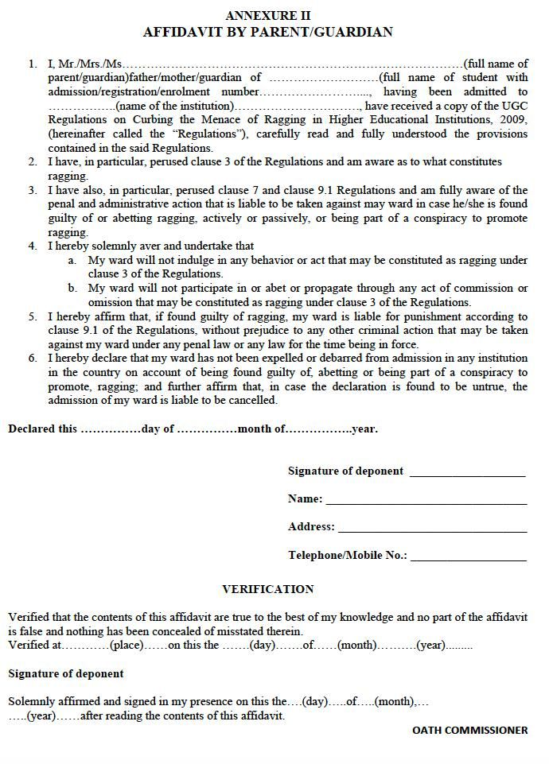

**Appendix - III : SAMPLE FORMAT FOR MEDICAL CERTIFICATE**

